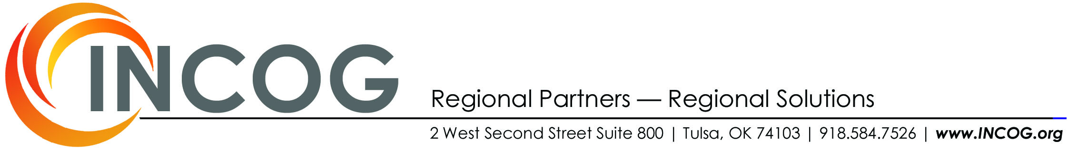

2012 Request for Proposals for the
TRANSPORTATION TECHNOLOGIES:
PUBLIC FLEET CONVERSION PROGRAM
Issued by:
INCOG and the Tulsa Area Clean Cities Coalition
December 20, 2011
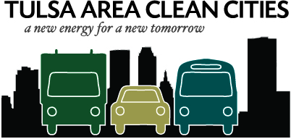

Project Proposal Deadline:
February 15, 2012

Table of Contents
Funding Opportunity Description 3
Background 3
General Information 3
Who Can Apply? 4
Project Categories 4
Additional Project Requirements 4
Funding Ratios 5
Utilization of Funds and Project Timeline 5
Limitations on Funds 5
Evaluation and Project Scoring 6
Project Proposal Format and Application Components 6
Grant Award Contract Dates and Process 6
Attachments 8
Attachment I TTMA MAP 8
Attachment II: List of Eligible Public Schools 9
ATTACHMENT III: Criteria Scoring Guide 10

Funding Opportunity

Background
The Congestion Mitigation and Air Quality (CMAQ) Improvement Program provides a flexible funding source for state and local governments to fund transportation projects and programs to help meet the requirements of the Clean Air Act (CAA) and its amendments. CMAQ money supports transportation projects that reduce mobile source emissions. Eligible activities include transit improvements, travel demand management strategies, traffic flow improvements, and public fleet conversions to cleaner fuels, among others.

The U.S. Department of Energy’s Clean Cities program is a voluntary, locally based, government and private industry partnership whose goal is to expand the use of alternatives to gasoline and diesel fuel, accelerate the deployment of alternative fuel vehicles and build a local alternative fuel infrastructure.

The Clean Cities program supports the Energy Policy Act of 1992 and the Clean Air Act and its 1990 Amendments, seeks to reduce national dependence on imported oil, and promotes the creation of commercial opportunities, new jobs and new businesses in the alternative fuels industry.

Since its 1997 designation, Tulsa Area Clean Cities’ partners and stakeholders have consistently sought to advance alternative fuel technology and the deployment of alternative fuel vehicles. The program is a catalyst for economic development in the region. The relationship all partners and stakeholders maintain is one that advances not only U.S. Department of Energy goals, but also Oklahoma commerce and economic development goals. Tulsa Area Clean Cities Coalition is supported by INCOG, the Oklahoma Department of Commerce and the U.S. Department of Energy.

The CMAQ program operates on a reimbursable basis. Funds are not provided until work is complete.

General Information
The procedures and guidelines set forth in this announcement apply to the award of CMAQ funds attributed to the Indian Nations Council of Governments (INCOG) and the Tulsa Transportation Management Area (TTMA) (See Attachment I) for the purpose of implementing a public fleet conversion grants program to be administered as a competitive grant process. INCOG’s Public Fleet Conversion Grants will allow member governments and their public school districts to access CMAQ funds for fleet conversions to clean fuel technologies to include alternative fuel vehicles and hybrid vehicles.
The applicant cost share requirement is a minimum of 20% for all categories. All funded projects will be one (1) year contract grants, beginning the day of issuance. If reimbursement requests are not submitted before the one (1) year contract end date, funds will no longer be available for that project.

Who Can Apply?
- Local units of government (cities towns and counties), public entities and public school districts located principally within the TTMA may apply for funding for the purchase of alternative fuel vehicles and hybrid vehicles. INCOG member entities’ public transit fleets are eligible to receive funds, but only for non-transit vehicles and /or alternative fuel vehicle refueling or recharging infrastructure.
- Public school districts located principally within the TTMA boundaries may apply for funding for the purchase of alternative fuel vehicles and hybrid vehicles. See Attachment II for a list of eligible public school districts.

Federal, state and fuel provider fleets covered under the Energy Policy Act of 1992 (EPAct 1992) are NOT eligible to receive funding under this solicitation.

This is a reimbursement program. All applicants must demonstrate an ability to fund and manage activities at the time they are undertaken. Applicants must be able to demonstrate the ability to provide required matching funds as applicable. The applicant(s) must finance the entire project until the project is completed and federal share is released for reimbursement (typically within 60 days of applicant submission of final invoice to INCOG).

Project Categories
For the purposes of this CMAQ-funded grant opportunity, and in keeping with current federal guidelines as outlined in the CMAQ Final Program Guidance published by the Federal Highway Administration in Federal Register Vol. 73, No. 203, Monday, October 20, 2008, funds may be awarded in the following categories:

- Alternative Fuel Refueling or Recharging Infrastructure
- Dedicated Alternative Fuel Vehicles (AFV’s) and Hybrid Vehicles
- Dedicated Alternative Fuel Off-Road equipment such as propane or compressed natural gas commercial mowers and forklifts

Additional Project Requirements
- Removal of one or more gasoline or diesel powered vehicles from its fleet. Fleet size is reduced or remains the same. (Conversions are exempt from this requirement).
- Visibly marking the project vehicle (or infrastructure) in such a way that promotes alternative fuels, clean air, and the Tulsa Area Clean Cities program. Tulsa Area Clean Cities will provide a sticker and guidelines on how the sticker should be placed on a CMAQ funded vehicle.
- Conversion of a vehicle must be to a less polluting fuel type for ozone causing pollutants.
- Upon request provide INCOG with periodic reporting which may include odometer readings, fuel consumption records, maintenance records, and written documentation of all other costs associated with the vehicle.
- Provide yearly petroleum reduction records to Tulsa Area Clean Cities on the 1st of February and continuing yearly thereafter for 3 years.

Funding Ratios
Eligible participant projects may be funded at a ratio up to 80% federal CMAQ funds and 20% local funds. The applicant cost share requirement is a minimum of 20% for all categories however additional points will be given to those projects that provide a higher level amount. See criteria scoring guide for further information.

Eligible public-private partnerships (PPP) infrastructure projects may be funded at the same ratio as public sector projects, however, all applicable federal and state incentives that will accrue to the private sector entity and/or any federal or state credits that may be partially or wholly transferred to the public sector must be disclosed.

For the purposes of the CMAQ funded grant opportunity, capital investments are defined as Level 1, Level 2, and Level 3 charging point/station equipment directly related to recharging electric batteries in highway-speed, plug-in electric vehicles; or equipment directly related to the compression of gaseous fuels, and equipment directly related to the storage and dispensing of both gaseous and liquid fuels into a motor vehicle. Capital investments exclude real estate and site development.

Utilization of Funds and Project Timeline
The amount of CMAQ funds available under the 2012 INCOG Public Fleet Conversion Grant Solicitation Announcement for projects in the TTMA is $150,000.

All awarded projects under the 2012 INCOG Public Fleet Conversion Grant Solicitation must be completed and invoiced with backup documentation as well as received by INCOG no later than one year from the signed contract date.

Limitations on Funds
Eligible local government members, public entities and public school districts located principally within the TTMA may apply for funding for 2012 INCOG Public Fleet Conversion Grant funding for which local match funds have been identified. Other federal grant funding or funds of federal origin cannot be utilized as matching funds. Additionally, if other awards, incentive, rebates, transferred tax credit or pass-though incentives will be utilized in a project, that amount of financial assistance and its purpose must be disclosed.

INCOG reserves the right to negotiate the amount of a grant award. The maximum amount of funding available under this solicitation announcement is $150,000. INCOG anticipates awarding approximately 5 to 8 grants.

Evaluation and Project Scoring
Each proposal will be rated under a points system based on a total of 20 points. Bonus points can be given to those proposals utilizing available OEM vehicle technologies, proposals using a “buy local” strategy, dramatically improve air quality and/or have a unique proposal. Awards will be made on a competitive basis. Only complete project applications submitted by the application deadline will be considered. A review committee consisting of INCOG staff will review each proposal and will assign points to each, based on the criteria described. Proposals will then be ranked and funding recommendations made according to ranking. INCOG reserves the right to reject any or all proposals or to make fewer awards than anticipated. In appropriate circumstances, INCOG reserves the right to partially fund proposals by funding discrete portions or phases of proposed projects. If INCOG decides to partially fund a project, it will do so in a manner that does not prejudice any applicants or affect the basis upon which the proposal or portion thereof, was evaluated and selected for award, thereby maintaining the integrity of the competition and selection process.

Projects will be evaluated and scored according to the following 5 criteria:
- Project Visibility and Public Awareness
- Level of Matching Funds
- Percent of Fleet Currently using Alternative Fuels
- Project Viability and Likelihood of Long-term Success
- Alternative Fueling Vehicle Refueling/Recharging Capacity
Each project will be evaluated by determining how well the project rates on each of the applicable criteria. Scoring details and definitions are detailed in Attachment III.

Project Proposal Format and Application Components
All proposals submitted must utilize the application procedures packet and the forms contained within.
Tulsa Area Clean Cities Stakeholder
- Applicant must be a stakeholder in good standing with Tulsa Area Clean Cities. Tulsa Area Clean Cities stakeholders must have a signed Stakeholder Memorandum of Understanding (MOU) on file with INCOG. MOU’s can be found at www.tulsacleancities.com.

Grant Award Contract Dates and Process
Notification of awarded projects is anticipated on or before March 23, 2012. Award recipients will be notified by telephone and/or email as well as posted on www.TulsaCleanCities.com.
Project award recipients will enter into an executable contract with INCOG prior to any project activity or purchase. This contract process may be 30 to 60 days after award notification. The executable grant award contracts will be twelve months in length, define reimbursement terms, record-keeping obligations and all requirements pursuant to the use of CMAQ funds.
Please submit Project Proposals electronically (PDF’s only) to mwebber@incog.org:
Meredith Webber
Tulsa Area Clean Cities Coordinator, INCOG
2 West Second Street Suite 800, Tulsa, OK 74103
(918) 579-9434
Proposals are due no later than 4:00 p.m., February 15, 2012

Attachments

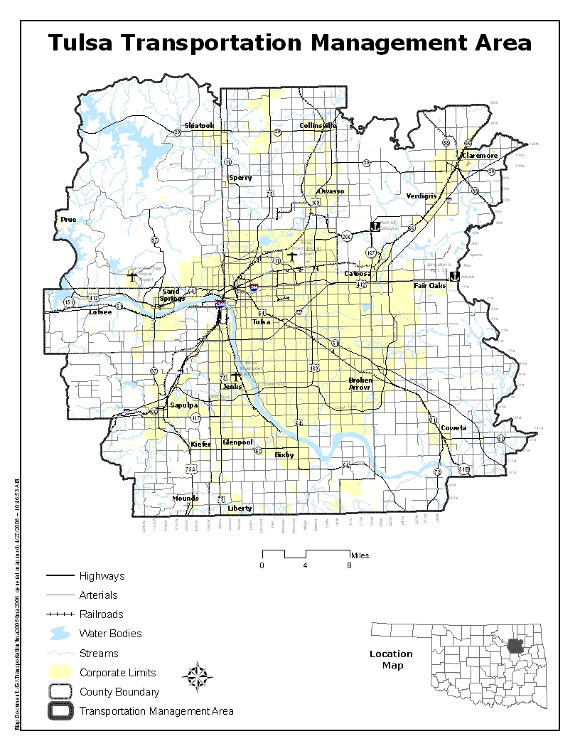
Attachment I TTMA MAP

Attachment II: List of Eligible Public Schools
- Berryhill Public Schools
- Bixby Public Schools
- Broken Arrow Public Schools
- Catoosa Public Schools
- Central Technology
- Claremore Public Schools
- Collinsville Public Schools
- Coweta Public Schools
- Glenpool Public Schools
- Jenks Public Schools
- Kiefer Public Schools
- Mounds Public Schools
- Owasso Public Schools
- Sand Springs Public Schools
- Sapulpa Public Schools
- Skiatook Public Schools
- Sperry Public Schools
- Tulsa Public Schools
- Tulsa Technology
- Union Public Schools
- Verdigris Public Schools

ATTACHMENT III: Criteria Scoring Guide
Each proposal will be evaluated and scored according to the following 5 criteria:
- Project Visibility and Public Awareness (Maximum Points 10)
Points will be given for the visibility and public awareness of alternative fuel vehicle refueling, if applicable.
SCORE | DEFINITION
5-10 | Applicant entity promotes visibility and public awareness for clean fuel vehicle and/or refueling/recharging technologies in their viability plan. Applicant entity promotes refueling/recharging station to general public and clearly identifies vehicles running on alternative fuels through signage.
1-4 | Applicant entity promotes refueling/recharging station to general public and clearly identifies vehicles running alternative fuels through signage.
0 | Applicant entity promotes no visibility or public awareness for clean fuel vehicle and/or refueling/recharging technologies.

- Level of Matching Funds (Maximum Points 5)
Points will be given for the required funding match. Additional points will be given to applicants that provide a higher level match.
SCORE | PERCENT of MATCH
5 | 41% plus
4 | 36% - 40%
3 | 31% - 35%
2 | 26% - 30%
1 | 21% - 25%
0 | 20%

- Percent of Fleet Currently using Alternative Fuels (Maximum Points 6)
Points will be given to applications entities based on current percentage of their fleet currently using alternative fuels.
SCORE | PERCENT of FLEET ON ALTERNATIVE FUELS
6 | > 51%
5 | 50% - 40%
4 | 39% - 30%
3 | 29% - 20%
2 | 19% - 10%
1 | 9% - 1%

- Project Viability and Likelihood of Long-term Success (Maximum Points 3)
Points will be given to applications from entities that provide a viable plan for continued fleet incorporation of clean fuel technologies (vehicles and/or refueling, as applicable).
SCORE | DEFINITION
3 | Applicant entity provides a viable plan for continued incorporation of clean fuel vehicle and/or refueling/recharging technologies that does not depend on continued grant funding for long-term sustainability.
2 | Applicant entity provides a viable plan for continued incorporation of clean fuel vehicle and/or refueling/recharging technologies that depends on some amount of additional grant funding to have long-term sustainability.
1 | Applicant entity provides no plan for continued incorporation of clean fuel vehicle and/or refueling/recharging technologies.

- Alternative Fueling Vehicle Refueling/Recharging Capacity (Maximum Points 3)
Points will be given for the availability and viability of alternative fuel vehicle refueling, if applicable.
SCORE | DEFINITION
3 | Fleet has adequate refueling/recharging capacity to fuel its alternative fuel vehicles at its own facility.
2 | Fleet had adequate refueling/recharging capacity to fuel its alternative vehicles at a combination of its own refueling facility and nearby (within a 5 mile radius of fleet yard) public access and/or shared fleet refueling/recharging facilities.
1 | Fleet has adequate refueling/recharging capacity to fuel its alternative fuel fleet vehicles at nearby (within a 5 mile radius of fleet yard) public access or shared fleet refueling/recharging facilities.

